RAG Architecture. Vector Search Indexes
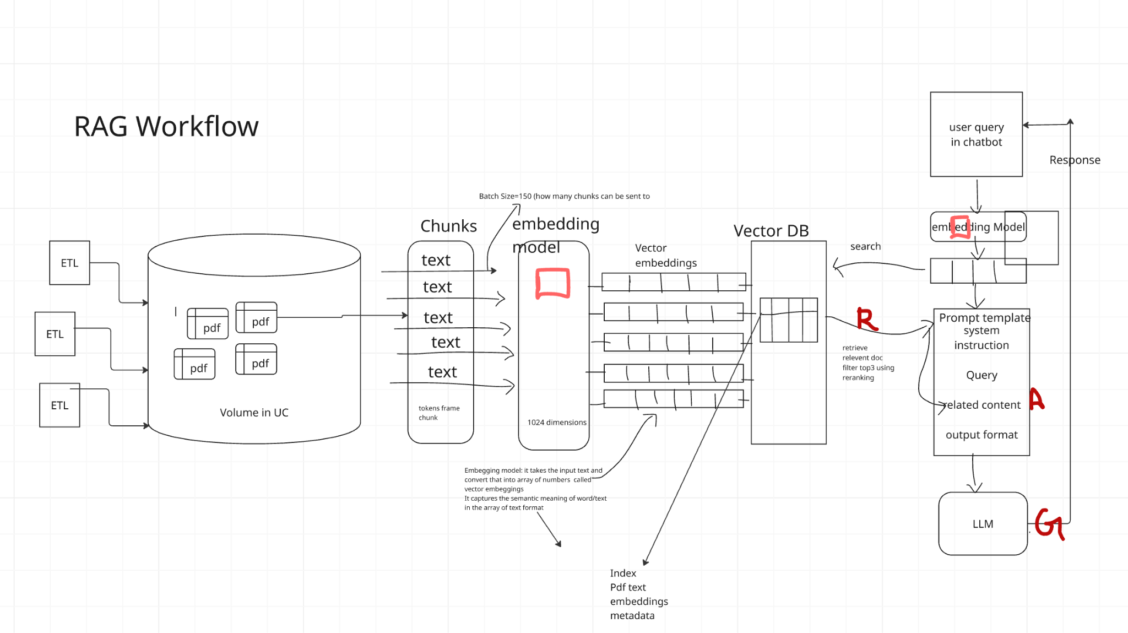

Vector Search Indexes💡
First: What’s a “vector”?
A vector is just a way to turn something into numbers so computers can understand it.
Example:
You can turn a picture, a sentence, or a song into numbers like this:
[0.1, 0.3, 0.7, 0.2]
Those numbers tell the computer what that thing means.
So now imagine you have millions of these lists of numbers — each one representing something (like millions of photos).
🧠 The Problem
You want to find things that are similar — for example:
“Find photos that look like this one.”
If you compare every photo one by one, it takes too long.
So you need a fast way to find similar ones.
⚙️ The Solution: “Vector Index”
A vector index is just a smart way to organize all your vectors so that searching becomes quick.
It’s like how you organize things in real life.
🏪 Example 1: FAISS → “The Shopping Mall”
You’re in a huge shopping mall with 1 million stores.
You want to find “shoe stores.”
Instead of checking every shop, the mall map (FAISS) tells you:
“Shoes are usually in section B.”
So you go directly to section B — much faster.
That’s what FAISS does:
It groups similar things together so you search in the right place.
🌳 Example 2: Annoy → “The Forest Paths”
You’re lost in a forest with thousands of trails.
Annoy builds a few random paths through the forest.
When you look for something, you walk along a few paths — not the whole forest — and you’ll usually find what you want quickly.
It’s not always perfect, but very fast.
🕸️ Example 3: HNSW → “The Friendship Network”
Imagine you want to find a person in a big city, but you don’t know where they live.
You ask your friends:
“Do you know someone who knows that person?”
Each friend introduces you to someone closer to them — until you reach your target.
That’s how HNSW works — it follows links between similar items.
🕵️ Example 4: ScaNN → “The Detective”
A detective has a long list of suspects.
He quickly removes most that don’t match and then carefully checks a few top ones.
That’s what ScaNN does:
It’s fast and also very accurate.
🧩 Super Short Summary
Tool | Easy Example | What It Does
FAISS | Like a mall map | Finds things in the right section
Annoy | Like random forest paths | Finds things quickly but roughly
HNSW | Like a network of friends | Finds things by following connections
ScaNN | Like a detective | Quickly filters and double-checks
🧩 Step 1: Think About What You’re Storing
Your Data | Example | What You Need
Text embeddings | Chat messages, documents | Fast, accurate search for meaning
Image embeddings | Photos, artwork | Similar image search
Audio embeddings | Songs, voice clips | Recommendation-like search
Mixed media | Text + image (multimodal) | Hybrid and scalable system
➡️ All these use vector representations — but how big and how many vectors you have will affect your choice.
⚙️ Step 2: Decide What Matters Most
Goal | Choose a Tool Like | Why
Speed (very fast search) | Annoy, HNSW, or ScaNN | Designed for quick lookups
Accuracy (find exact matches) | HNSW or ScaNN | They’re very precise
Memory efficiency (low RAM) | FAISS with PQ (product quantization) | Compresses data smartly
Scalability (huge data, billions of vectors) | FAISS, Milvus, Qdrant, Pinecone | Handles distributed systems
Easy to use | Qdrant, Weaviate, or Pinecone | Managed services, no setup needed
🚀 Step 3: Match Tool to Use Case
Use Case | Best Tool(s) | Why
Recommendation systems | Annoy, HNSW | Quick “find similar” tasks
Chatbots / semantic search | HNSW, ScaNN | Very accurate similarity search
Large-scale AI databases | FAISS, Milvus, Pinecone | Handles millions/billions of embeddings
Mobile or low-resource systems | Annoy | Lightweight and simple
🧠 Step 4: Combine Tools (Optional)
Sometimes, systems use two or more methods together:
- Example:
A company might use FAISS for the main database
and HNSW for re-ranking top matches for higher accuracy.
✅ Quick Summary
Question | Best Option
Want fast and simple? | Annoy
Want high accuracy? | HNSW
Want huge scale (millions of vectors)? | FAISS
Want Google-quality balance? | ScaNN
Want ready-to-use cloud service? | Pinecone, Qdrant, or Weaviate

Toolbox | Creator | Type | Main Algorithms / Techniques | Best For | Notes
FAISS | Meta (Facebook) | Library | - IVF (Inverted File Index) - PQ (Product Quantization) - HNSW - LSH (Locality-Sensitive Hashing) - Flat (Exact search) | Large-scale search (millions or billions of vectors) | Many options; needs tuning; fastest for massive datasets
ScaNN | Google | Library | - Tree + quantization + re-ranking (hybrid) | High-accuracy, fast text or image embeddings | Auto-tunes parameters; great balance of speed & accuracy
Annoy | Spotify | Library | - Random Projection Trees (Forest of Trees) | Simple, fast, low-memory searches | Very lightweight; great for small-to-medium datasets
HNSWlib | Open source | Library | - HNSW (Hierarchical Navigable Small World Graph) | High-accuracy search | Graph-based; used in Milvus, Qdrant, Weaviate
Milvus | Zilliz | Database / Platform | - HNSW - IVF_FLAT / IVF_PQ (from FAISS) - DiskANN | Enterprise-scale vector search | Distributed; integrates with FAISS & HNSWlib
Qdrant | Qdrant.io | Database / Service | - HNSW (custom-optimized) | Real-time semantic search | Easy setup; strong metadata + filters
Pinecone | Pinecone.io | Managed Cloud Service | - Proprietary (built on HNSW-like & FAISS-like methods) | Fully managed cloud vector DB | Zero setup, scalable, commercial service

Toolbox | You Install It? | Inside It | Used By
FAISS | ✅ Yes | Many search algorithms | Meta, Hugging Face
ScaNN | ✅ Yes | Google’s custom methods | Google, TensorFlow
Annoy | ✅ Yes | Tree-based search | Spotify
HNSWlib | ✅ Yes | Graph-based search | Used inside Milvus, Qdrant
Milvus | ☁️ Optional | FAISS + HNSW + others | Enterprise AI systems
Qdrant | ☁️ Optional | HNSW-based | Search apps, startups
Pinecone | ☁️ No (managed) | Proprietary mix | Cloud vector search users
🧱 Think of it Like Building a House
Each layer in that list is like a different part of a system, working together to make vector search possible.
1️⃣ Algorithm → 🧮 “The math or method”
This is the core logic — the actual “trick” used to find similar vectors quickly.
Examples:
- HNSW → builds a network of connected points.
- IVF (Inverted File Index) → divides data into clusters.
- PQ (Product Quantization) → compresses data to save space.
🧠 These are formulas or mathematical ideas, not tools you install.
2️⃣ Library → 🧰 “A toolbox of algorithms”
A library collects several algorithms and lets programmers use them easily.
Examples:
- FAISS (by Meta) includes HNSW, IVF, PQ, etc.
- Annoy uses random tree algorithms.
- ScaNN has Google’s hybrid algorithm.
- HNSWlib is focused only on HNSW.
So the library is what implements those algorithms in code — you can import it into Python and start using it.
3️⃣ Database → 🗄️ “A full system that uses libraries”
A vector database uses one or more of these libraries under the hood to handle:
- Data storage
- Indexing
- Search
- Filtering
- Scaling across multiple computers
Examples:
- Milvus uses FAISS and HNSWlib internally.
- Qdrant uses HNSWlib inside.
- Pinecone uses custom versions similar to FAISS/HNSW.
You can think of these as ready-made services that already include the libraries, so you don’t have to manage indexes manually.
4️⃣ Application → 💬 “The final product that users see”
This is what uses the database to solve a real-world problem:
Examples:
- Chatbot → finds similar messages or answers using a vector database.
- Recommender system → finds similar movies, products, or songs.
- Search engine → finds similar documents or images.
📊 So, putting it all together:
Layer | Example | Role
Algorithm | HNSW, IVF, PQ | Mathematical method for fast search
Library | FAISS, Annoy, ScaNN | Implements algorithms for developers
Database | Milvus, Qdrant, Pinecone | Manages data and uses libraries inside
Application | Chatbot, recommender, search engine | Uses the database to serve users
💬 Analogy: Making Coffee ☕
Step | Equivalent | Example
Algorithm | Coffee recipe | “Brew at 90°C for 3 mins”
Library | Coffee machine | FAISS = machine that follows the recipe
Database | Café | Manages many machines, keeps beans, serves customers
Application | Your coffee order | The final latte you drink ☕
So when we say:
“Milvus, Qdrant, and Pinecone use FAISS or HNSWlib inside to do the heavy lifting,”
we mean:
They depend on those libraries’ algorithms to actually find similar vectors quickly, while the database handles all the management and scaling.

MLOPS|LLMOPS
|
MOSAIC AI
|
mlflow

Compound AI.
Please prepare a detailed market report on electric cars and suggest top 3 investment options.
“company” (Compound AI system) works step-by-step:
- Client Request → “Make a report on electric cars.”
- CEO (LLM) → Understands the request and creates a plan.
- Project Manager (Orchestrator) → Breaks it into tasks.
- Research Team (Retriever) → Finds recent articles & stats.
- Operations Team (Tools/APIs) → Runs data analysis or SQL queries.
- Experts (Domain Models) → Build charts, detect trends.
- Secretary (Memory) → Keeps context for next time.
- CEO (LLM) → Writes and delivers the final polished report.
Result → A coordinated, intelligent, and efficient response, just like a real company
List the importance of topic1?
Agent :
Brain: GPt5
Tools: retriever, python, YouTube
Agent:
LLM—>brain
Tools: SQL,python
Retriever
Comparison
Core | LlamaIndex | LangChain | DSPy | Haystack
Core Idea | Connect data to LLMs efficiently | Orchestrate LLM workflows (chains, agents) | Learnable prompting / reasoning optimization | Open-source framework for search + QA
Focus Area | Data indexing, vector search | Agent reasoning, multi-step logic | Structured prompting, self-improvement | Document retrieval + generation
Best For | RAG applications | Chatbots, agents, assistants | Improving reasoning accuracy | Enterprise search, QA bots
Data Handling | Very strong (multiple connectors: SQL, PDFs, APIs, etc.) | Basic; integrates with LlamaIndex | Minimal (focuses on logic, not data) | Strong (retrievers, readers, pipelines)
Ease of Use | Easy to start | Moderate (many components) | Complex (research-style) | Moderate to complex
Production Readiness | Medium (integrates well) | High (widely adopted) | Low–medium (still academic) | High (robust deployment tools)
Example Use | “Search company policies PDF and answer” | “Book an appointment and send a message” | “Optimize reasoning steps for a math question” | “Search FAQs and return precise answer”
LLM Reasoning Frameworks
Sno | Framework | Core Idea (How it Thinks) | Best Use Cases | Simple Analogy
1 | Chain-of-Thought (CoT) | Thinks step-by-step before answering | Logical, mathematical, and analytical reasoning | Solving a math problem on paper step-by-step
2 | ReAct (Reason + Act) | Alternates between reasoning and taking tool actions | Tool use (search, API calls, database queries) | Researcher who thinks, tests, observes, and concludes
3 | Reflexion | Self-evaluates and refines its own output | Code generation, writing, self-correction loops | Writer editing and improving their own draft
4 | Plan-and-Execute (PaE) | Plans first, then executes the plan step-by-step | Long or complex multi-step tasks | Manager (planner) and engineer (executor) working together
5 | Tree-of-Thought (ToT) | Explores multiple reasoning paths before choosing the best | Creative thinking, brainstorming, strategic planning | Chess player evaluating several moves before choosing one
6 | Graph-of-Thought (GoT / LangGraph) | Uses a network of reasoning nodes that collaborate | Multi-agent systems, complex workflows | Team of experts each handling connected subtasks
7 | Toolformer / Function Calling | Decides when and how to call external tools or APIs | Automation, integration with systems (SQL, APIs) | Smart assistant who knows when to “Google” or use an app
8 | AutoGPT / Autonomous Loop | Works toward a goal using plan → execute → reflect cycles | Goal-driven or autonomous agents | Employee given a target who works independently until done
9 | Debate / Deliberation | Multiple LLMs argue and refine each other’s ideas | Decision quality, risk reduction, bias control | Panel of experts debating before reaching consensus
10 | Meta-Reasoning / Orchestrator | Decides which reasoning framework best fits a task | Adaptive or compound AI systems | Supervisor assigning each task to the right specialist
Which Framework to Use
Goal / Scenario | Recommended Framework
Step-by-step reasoning or math problems | Chain-of-Thought
Tasks needing tool or API use | ReAct / Toolformer
Writing or coding with self-correction | Reflexion
Multi-step or long workflows | Plan-and-Execute
Creative exploration or idea generation | Tree-of-Thought
Coordinating multiple agents | Graph-of-Thought
Fully autonomous goal-seeking | AutoGPT
Ensuring correctness via debate | Debate Framework
Adaptive reasoning (choosing best style dynamically) | Meta-Reasoning Controller
Compound AI system
Def
Types
Chain(non agent)
Agent(agent workflow)
Frameworks: Langchain, llama index, dspy,haystack
How agent will decide the actions to take as it is non deterministic
: planning logic
React
Tool calling
Planning
Multi agent
—-----------

